# [04 - Iteration Control Structures](https://www.rajalakshmicolleges.net/moodle/course/view.php?id=84&section-4)

##### For example:

.

**Department of Computer Science and Engineering** | **Rajalakshmi Engineering College**

68

|  |  |
| --- | --- |
| **Input** | **Result** |
| 20 | 1 2 4 5 10 20 |

**Ex. No. : 4.1 Date:**

.

**Department of Computer Science and Engineering** | **Rajalakshmi Engineering College**

69

**Register No.: Name:**

## [Factors of a number](https://www.rajalakshmicolleges.net/moodle/mod/quiz/view.php?id=5720)

Determine the factors of a number (i.e., all positive integer values that evenly divide into a number).

**PROGRAM:-**

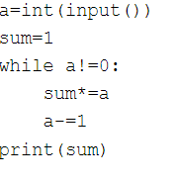

##### For example:

.

**Department of Computer Science and Engineering** | **Rajalakshmi Engineering College**

70

|  |  |
| --- | --- |
| **Input** | **Result** |
| 292 | 1 |
| 1015 | 2 |
| 108 | 3 |
| 22 | 0 |

**Ex. No. : 4.2 Date:**

.

**Department of Computer Science and Engineering** | **Rajalakshmi Engineering College**

71

**Register No.: Name:**

## [Non](https://www.rajalakshmicolleges.net/moodle/mod/quiz/view.php?id=5717) Repeated Digit Count

Write a program to find the count of non-repeated digits in a given number N. The number will be passed to the program as an input of type int.

Assumption: The input number will be a positive integer number >= 1 and <= 25000. Some examples are as below.

If the given number is 292, the program should return 1 because there is only 1 non-- repeated digit '9' in this number

If the given number is 1015, the program should return 2 because there are 2 non- repeated digits in this number, '0', and '5'.

If the given number is 108, the program should return 3 because there are 3 non-- repeated digits in this number, '1', '0', and '8'.

If the given number is 22, the function should return 0 because there are NO non-- repeated digits in this number.

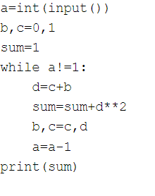

Example1: if the given number N is 7, the method must return 2 Example2: if the given number N is 10, the method must return 1

.

**Department of Computer Science and Engineering** | **Rajalakshmi Engineering College**

72

##### For example:

|  |  |
| --- | --- |
| **Input** | **Result** |
| 7 | 2 |
| 10 | 1 |

**Ex. No. : 4.3 Date:**

.

**Department of Computer Science and Engineering** | **Rajalakshmi Engineering College**

73

**Register No.: Name:**

## Prime Checking

Write a program that finds whether the given number N is Prime or not. If the number is prime, the program should return 2 else it must return 1.

Assumption: 2 <= N <=5000, where N is the given number.

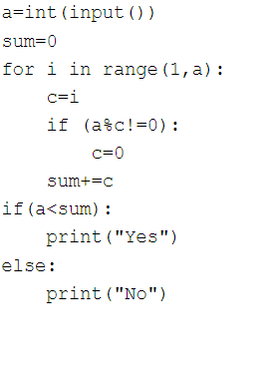

Input Format:

.

**Department of Computer Science and Engineering** | **Rajalakshmi Engineering College**

74

Integer input from stdin. Output Format:

Perfect square greater than N. Example Input:

10

Output: 16

**Ex. No. : 4.4 Date:**

.

**Department of Computer Science and Engineering** | **Rajalakshmi Engineering College**

75

**Register No.: Name:**

## Next Perfect Square

Given a number N, find the next perfect square greater than N.

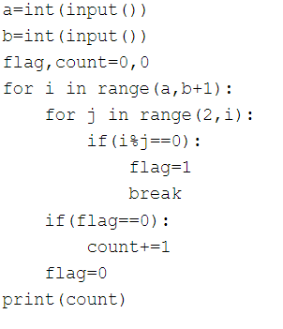

NOTE: Fibonacci series looks like –

.

**Department of Computer Science and Engineering** | **Rajalakshmi Engineering College**

76

0, 1, 1, 2, 3, 5, 8, 13, 21, 34, 55, . . . and so on.

i.e. Fibonacci series starts with 0 and 1, and continues generating the next number as the sum of the previous two numbers.

* first Fibonacci number is 0,
* second Fibonacci number is 1,
* third Fibonacci number is 1,
* fourth Fibonacci number is 2,
* fifth Fibonacci number is 3,
* sixth Fibonacci number is 5,
* seventh Fibonacci number is 8, and so on.

**For example: Input:**

**7**

**Output 8**

**Ex. No. : 4.5 Date:**

.

**Department of Computer Science and Engineering** | **Rajalakshmi Engineering College**

77

**Register No.: Name:**

## Nth Fibonacci

Write a [program](https://www.rajalakshmicolleges.net/moodle/mod/quiz/view.php?id=3478) to return the nth number in the fibonacci series. The value of N will be passed to the [program](https://www.rajalakshmicolleges.net/moodle/mod/quiz/view.php?id=3478) as input.

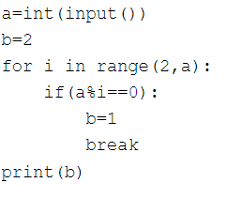

Input Format:

.

**Department of Computer Science and Engineering** | **Rajalakshmi Engineering College**

78

Single Integer Input from stdin. Output Format:

Yes or No. Example Input: 175

Output:

Yes Explanation

1^1 + 7^2 +5^3 = 175

Example Input: 123

Output:

No

##### For example:

|  |  |
| --- | --- |
| **Input** | **Result** |
| 175 | Yes |
| 123 | No |

**Ex. No. : 4.6 Date:**

.

**Department of Computer Science and Engineering** | **Rajalakshmi Engineering College**

79

**Register No.: Name:**

## Disarium Number

A Number is said to be Disarium number when the sum of its digit raised to the power of their respective positions becomes equal to the number itself. Write a [program](https://www.rajalakshmicolleges.net/moodle/mod/quiz/view.php?id=3478) to print number is Disarium or not.

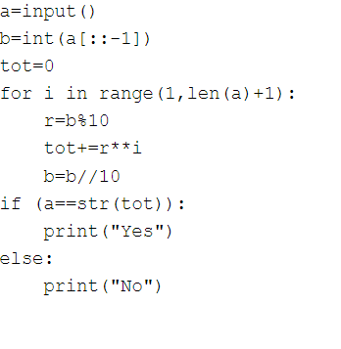

Sample Test Cases Test Case 1

.

**Department of Computer Science and Engineering** | **Rajalakshmi Engineering College**

80

Input 4

Output 1234

Explanation:

as input is 4, have to take 4 terms. 1 + 11 + 111 + 1111

Test Case 2 Input

6

Output 123456

##### For example:

|  |  |
| --- | --- |
| **Input** | **Result** |
| 3 | 123 |

**Ex. No. : 4.7 Date:**

.

**Department of Computer Science and Engineering** | **Rajalakshmi Engineering College**

81

**Register No.: Name:**

## Sum of Series

Write a program to find the sum of the series 1 +11 + 111 + 1111 + . . . + n terms (n will be given as input from the user and sum will be the output)

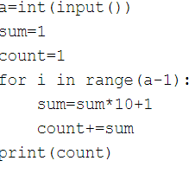

##### For example:

.

**Department of Computer Science and Engineering** | **Rajalakshmi Engineering College**

82

|  |  |
| --- | --- |
| **Input** | **Result** |
| 292 | 2 |
| 1015 | 3 |

**Ex. No. : 4.8 Date:**

.

**Department of Computer Science and Engineering** | **Rajalakshmi Engineering College**

83

**Register No.: Name:**

## Unique Digit Count

Write a program to find the count of unique digits in a given number N. The number will be passed to the program as an input of type int.

Assumption: The input number will be a positive integer number >= 1 and <= 25000. For e.g.

If the given number is 292, the program should return 2 because there are only 2 unique digits '2' and '9' in this number

If the given number is 1015, the program should return 3 because there are 3 unique digits in this number, '1', '0', and '5'.



Input Format:

.

**Department of Computer Science and Engineering** | **Rajalakshmi Engineering College**

84

Single Integer input. Output Format:

Output displays Yes if condition satisfies else prints No. Example Input:

14

Output:

Yes

Example Input: 13

Output: No

**Ex. No. : 4.9 Date:**

.

**Department of Computer Science and Engineering** | **Rajalakshmi Engineering College**

85

**Register No.: Name:**

## Product of single digit

Given a positive integer N, check whether it can be represented as a product of single digit numbers.

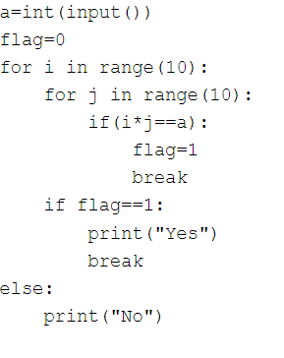

Input Format: Single integer input. Output Format:

.

**Department of Computer Science and Engineering** | **Rajalakshmi Engineering College**

86

Yes or No. Example Input: 24

Output:

Yes

Example Input: 26

Output:

No

##### For example:

|  |  |
| --- | --- |
| **Input** | **Result** |
| 24 | Yes |

**Ex. No. : 4.10 Date:**

.

**Department of Computer Science and Engineering** | **Rajalakshmi Engineering College**

87

**Register No.: Name:**

## Perfect Square After adding One

Given an integer N, check whether N the given number can be made a perfect square after adding 1 to it.

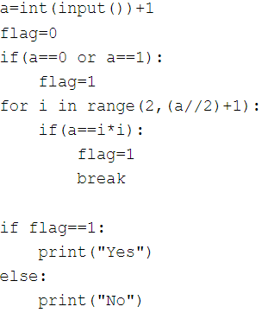

.

**Department of Computer Science and Engineering** | **Rajalakshmi Engineering College**

88